1 Why Java Not 100% OO Language

- Primitive Data Type – int , float
- They Provided Wrapper Classes

2 Why Pointer Not allowed in Java?
- Unsafe :- They are unsafe – Faulty implementation – Memory manipulation
- Complex:- Increase complexity of program
- JVM Manage memory :- JVM manage memory to restrict direct pointer discourage

3 Jit Compiler Java

JAVA SOURCE CODE - > JDK -> BYTE CODES -> JRE(Interpreter + JIT Compiler)
BYTE CODE TO MACHINE CODE
- Interpreter go line by line -> convert machine language -> Slow
- Efficiency performance optimization
- Compiling rather then interpreting JIT

4 Why String Immutable in Java
- String pool can change: - If not immutable can change from anywhere.
- Security :- Shared in different area like file system,networking , db connection, string allow security once created not change. No body change reference.

5 What is Marker Interface?
- No data member , No function , Empty
- Tells compiler specific metadata. This is special.
- Serializable , Clonable

6 Can you override private or static method in Java?
- Cant
- private cant visible in child
- static method then call method hiding if same name and return type.

7 Does finally always execute?
- System.exit()
- System crashes.

8 What method does object class have?
- Clone() - clonenotsupportedexception
- equals(Object o)
- finalize – before garbadge collection.
- getClass()- return runtime class of object.
- Int Hashcode() - return hashcode value of object
- tostring – string representation of object.
- Notify
- notifyall
- wait

How to make class Immutable?

- Final – cant extended
- Private fields – cant access outside
- Dont provide setter – cant set variable
- Make mutable variable final so can set value only once
- Initialize all variable via constrcutor performing deep copy,
- Performing cloning of object in getter method rather then copy.

Singleton Class
- only one instance created any given time jvm
- public class Animal{
private static Animal = null;
private Animal(){}

public static Animal getInstance(){
if(single_instance == null){
single_instance = new Animal();
}

return single_instance;
}
}

- Private contstructor
- public Static method -
- private static variable

Java always passes arguments by value, NOT by reference.
public class Main {

public static void main(String[] args) {
Foo f = new Foo("f");
changeReference(f); // It won't change the reference!
modifyReference(f); // It will modify the object that the reference variable "f" refers to!
}

public static void changeReference(Foo a) {
Foo b = new Foo("b");
a = b;
}

public static void modifyReference(Foo c) {
c.setAttribute("c");
}
}

Access Modifier
- Private:
  - The access level of a private modifier is only within the class.
  - It cannot be accessed from outside the class.
- Default:
  - The access level of a default modifier is only within the package.
  - It cannot be accessed from outside the package.
  - If you do not specify any access level, it will be the default.
- Protected:
  - The access level of a protected modifier is within the package and outside the package through child class.
  - If you do not make the child class, it cannot be accessed from outside the package.
- Public:
  - The access level of a public modifier is everywhere.
  - It can be accessed from within the class, outside the class, within the package and outside the package.

Final
- Variable – Cant change value of it
- method – Cant override it
- class - Cant extend it

Static
- Variable (also known as a class variable)
  - Common property for the all the object.e.g.Company Name emp Schoonl name
  - Save Memory – e.g. 50 student same school
  - Same memory location
- Method (also known as a class method)
  - Belong To Class :- A static method belongs to the class rather than the object of a class.
  - Invoke With Class without Object :- A static method can be invoked without the need for creating an instance of a class.
  - Can Access Static Data member can change it :- A static method can access static data member and can change the value of it.
  - The static method can not use non static data member or call non-static method directly.this and super cannot be used in static context.

- Block

Java static block
- Is used to initialize the static data member.
- It is executed before the main method at the time of classloading.

- Nested class

Java static nested class
- A static class i.e. created inside a class is called static nested class in java. It cannot access non-static data members and methods. It can be accessed by outer class name.
- It can access static data members of outer class including private.
- Static nested class cannot access non-static (instance) data member or method.
- Java static nested class example with instance method
class TestOuter1{
static int data=30;
static class Inner{
void msg(){System.out.println("data is "+data);}
}
public static void main(String args[]){
TestOuter1.Inner obj=new TestOuter1.Inner();
obj.msg();
}
}

Volatile:

The Volatile keyword is used to mark the JVM and thread to read its value from primary memory and
not utilize cached value present in the thread stack.
It is used in concurrent programming in java.

class GFG extends Thread {
volatile boolean working = true;
public void run()
{
long count = 0;
while (working) {
count++;
}
System.out.println("Thread terminated."+ count);
}
// Driver code
public static void main(String[] args)
throws InterruptedException
{
GFG test = new GFG();
test.start();
Thread.sleep(100);
System.out.println("After Sleeping in Main");
test.working = false;
test.join();
System.out.println("Working set to "
+ test.working);
}
}
Transient
- Java transient keyword is used in serialization.
- If you define any data member as transient, it will not be serialized.

Final Finally and Finalize
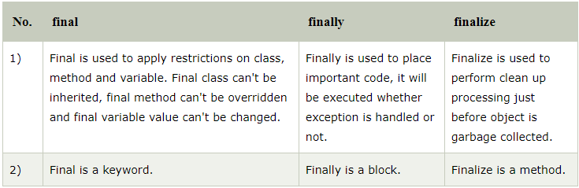

Super Keyword in Java
The super keyword in Java is a reference variable which is used to refer immediate parent class object.

Usage of Java super Keyword
- Refer Immidiate Parent Class :- super can be used to refer immediate parent class instance variable.
- Refre Immidiate Parent Class Method :- super can be used to invoke immediate parent class method.
- Invoked Immidiate Parent Class Construcotr :- super() can be used to invoke immediate parent class constructor.
Serialization
- Writing state of object in byte
- state of object in byte :- Serialization in Java is a mechanism of writing the state of an object into a byte-stream.
- It is mainly used in Hibernate, RMI, JPA, EJB and JMS technologies.
- Reverse operation call deserialization.
- Seriazlization – Interface – Must implement for the serialization
- ObjectOutputStream - writeObject readObject
- It is mainly used to travel object's state on the network

SerialVersionUID : SerialVersionUID is used to ensure that during deserialization the same class (that was used during serialize process) is loaded.

Problem of depending on default SerialVersionUID generated by JVM :
- Both sender and receiver should use the same JVM with respect to platform and version also. Otherwise receiver unable to deserialize because of different SerialVersionUID.
- After serialization if there is any change in .class file at receiver side then receiver unable to deserialize.
- Performance problem due to complex algorithm

What if we change serialversionuid?
java.io.InvalidClassException:

Java Synchronization
- Synchronization is a process of handling resource accessibility by multiple thread requests.
- The main purpose of synchronization is to avoid thread interference. At times when more than one thread try to access a shared resource,
- we need to ensure that resource will be used by only one thread at a time.

import java.util.concurrent.BlockingQueue;
import java.util.concurrent.LinkedBlockingQueue;
import java.util.logging.Level;
import java.util.logging.Logger;

public class ProducerConsumerPattern {

public static void main(String args[]){

//Creating shared object
BlockingQueue sharedQueue = new LinkedBlockingQueue();

//Creating Producer and Consumer Thread
Thread prodThread = new Thread(new Producer(sharedQueue));
Thread consThread = new Thread(new Consumer(sharedQueue));

//Starting producer and Consumer thread
prodThread.start();
consThread.start();
}

}

//Producer Class in java
class Producer implements Runnable {

private final BlockingQueue sharedQueue;

public Producer(BlockingQueue sharedQueue) {
this.sharedQueue = sharedQueue;
}

@Override
public void run() {
for(int i=0; i<10; i++){
try {
System.out.println("Produced: " + i);
sharedQueue.put(i);
} catch (InterruptedException ex) {
Logger.getLogger(Producer.class.getName()).log(Level.SEVERE, null, ex);
}
}
}

}

//Consumer Class in Java
class Consumer implements Runnable{

private final BlockingQueue sharedQueue;

public Consumer (BlockingQueue sharedQueue) {
this.sharedQueue = sharedQueue;
}

@Override
public void run() {
while(true){
try {
System.out.println("Consumed: "+ sharedQueue.take());
} catch (InterruptedException ex) {
Logger.getLogger(Consumer.class.getName()).log(Level.SEVERE, null, ex);
}
}
}

}
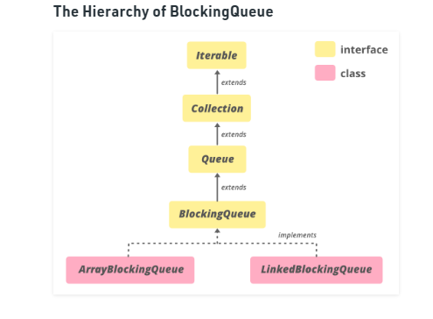
- Java BlockingQueue interface implementations are thread-safe.
- All methods of BlockingQueue are atomic in nature and use internal locks or other forms of concurrency control
Producer Consumer through Java Thread
public class ProducerConsumer
{
public static void main(String[] args)
{
Shop c = new Shop();
Producer p1 = new Producer(c, 1);
Consumer c1 = new Consumer(c, 1);
p1.start();
c1.start();
}
}
class Shop
{
private int materials;
private boolean available = false;
public synchronized int get()
{
while (available == false)
{
try
{
wait();
}
catch (InterruptedException ie)
{
}
}
available = false;
notifyAll();
return materials;
}
public synchronized void put(int value)
{
while (available == true)
{
try
{
wait();
}
catch (InterruptedException ie)
{
ie.printStackTrace();
}
}
materials = value;
available = true;
notifyAll();
}
}
class Consumer extends Thread
{
private Shop Shop;
private int number;
public Consumer(Shop c, int number)
{
Shop = c;
this.number = number;
}
public void run()
{
int value = 0;
for (int i = 0; i < 10; i++)
{
value = Shop.get();
System.out.println("Consumed value " + this.number+ " got: " + value);
}
}
}
class Producer extends Thread
{
private Shop Shop;
private int number;

public Producer(Shop c, int number)
{
Shop = c;
this.number = number;
}
public void run()
{
for (int i = 0; i < 10; i++)
{
Shop.put(i);
System.out.println("Produced value " + this.number+ " put: " + i);
try
{
sleep((int)(Math.random() * 100));
}
catch (InterruptedException ie)
{
ie.printStackTrace();
}
}
}
}

Difference between start and run method

- start thread created – run exceucuted
- cant twice call twice

implements runnable better

Busy Spinning?
- The busy waiting is a wait strategy, where one thread waits for a condition to become true, but instead of calling the wait or sleep method and releasing the CPU, it just spins. This is particularly useful if the condition is going to be true quite quickly i.e. in a millisecond or microsecond.

Wait vs Sleep
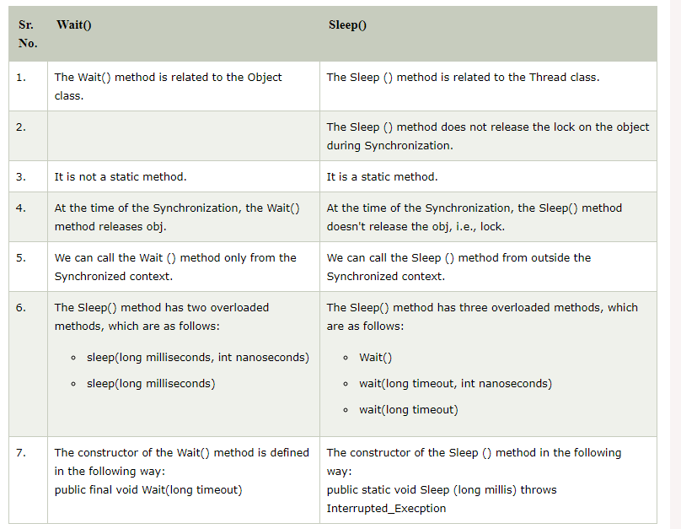
'
Checked vs Unchecked Exception

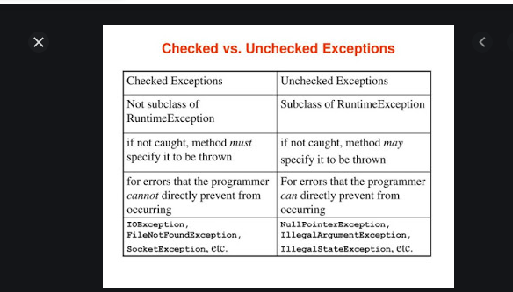

Extends Exception
public class IncorrectFileNameException extends Exception {
public IncorrectFileNameException(String errorMessage) {
super(errorMessage);
}
}

Throw vs Throws
There are many differences between throw and throws keywords. A list of differences between throw and throws are given below:
No. | throw | throws
1) | Java throw keyword is used to explicitly throw an exception. | Java throws keyword is used to declare an exception.
2) | Checked exception cannot be propagated using throw only. | Checked exception can be propagated with throws.
3) | Throw is followed by an instance. | Throws is followed by class.
4) | Throw is used within the method. | Throws is used with the method signature.
5) | You cannot throw multiple exceptions. | You can declare multiple exceptions e.g.  public void method()throws IOException,SQLException.
void m()throws ArithmeticException{
- throw new ArithmeticException("sorry");
- }

